*Core Java - Inheritance Assignment*

**Instructions:**

Below you will find a series of assignments that you will complete in this exercise. You will need to create a new project folder for this task and name it **Java_Assignment_5_Inheritance**. You can use the default settings when creating the new project.

For each of the below assignments you will create new classes as specified below. Pay attention to the package name as you will use two packages, **model** and **main** in these exercises as indicated below in the assignment directions.

Most classes will NOT declare a main() method except for the Application.java file that you will write for a package. In your assignments, you will execute the main() method of the Application.java file.

**Assignments**

1. Write a class named **Person** that declares instance variables name (String) and age(int); they should be marked **protected**. Create a default no-arg constructor for Person. Create another class named **AwesomePerson** that extends Person. AwesomePerson should declare a method talk() that prints its name and age properties. AwesomePerson should also have its own default, no-arg constructor.

In an Application class, instantiate an AwesomePerson and call its talk() method.

Place the Person and AwesomePerson in the package, model. Place the Application.java file in the package, main.

1. Create a class named **ReallyAwesomePerson** that extends AwesomePerson. Overload the inherited talk() method to print a statement of your choice. Update the constructors of Person, AwesomePerson and ReallyAwesomePerson to print a message of your choice.

Update the Application class from the above assignment to instantiate a ReallyAwesomePerson and run its talk() method that you overloaded.

Notice the order of the constructors executed when you run the application.

ReallyAwesomePerson.java should be in the package, model.

1. Create a class named GameObject that declares an update() method with a void return type. Place this in a new package called, game. Create two other classes, Player and Enemy that both extend GameObject. Place them in the same package as GameObject. Override the update() method for both Player and Enemy to do print a message of your choice.

Create a fourth class, Game, in the game package. Write a main() method. In its main() method, create two GameObjects that are a Player and an Enemy.

For example:

|  |
| --- |
| GameObject player = new Player(); |

Call the update() method on both objects.

**Goal:**

The purpose of this assignment is to provide you practice with writing classes that follow an inheritance hierarchy, using method overriding and overloading techniques. You will utilize the **main()** method of your Application and Game classes to execute a particular goal of the assignment.

By the end of this assignment, you will have 1 new project folder with the associated classes that meet the requirements mentioned above.

**Helpful Notes**

Project Structure:

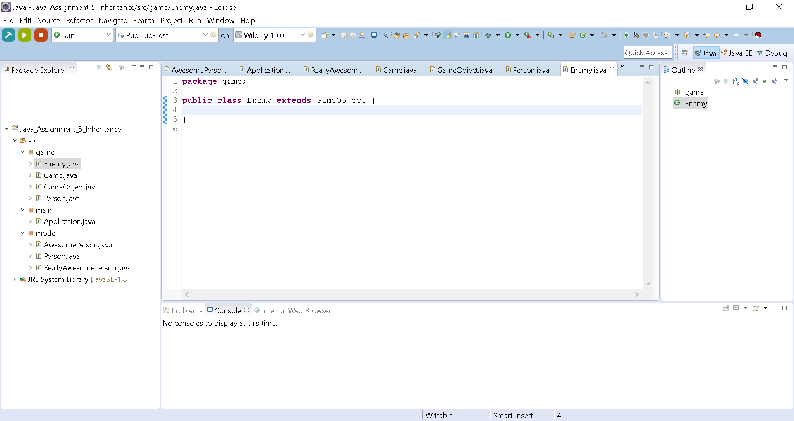

* Your project structure should resemble the above. Note that the name of the project is **Java_Assignment_5_Inheritance** and all class files are named according to the associated assigned number

Assignment Classes:

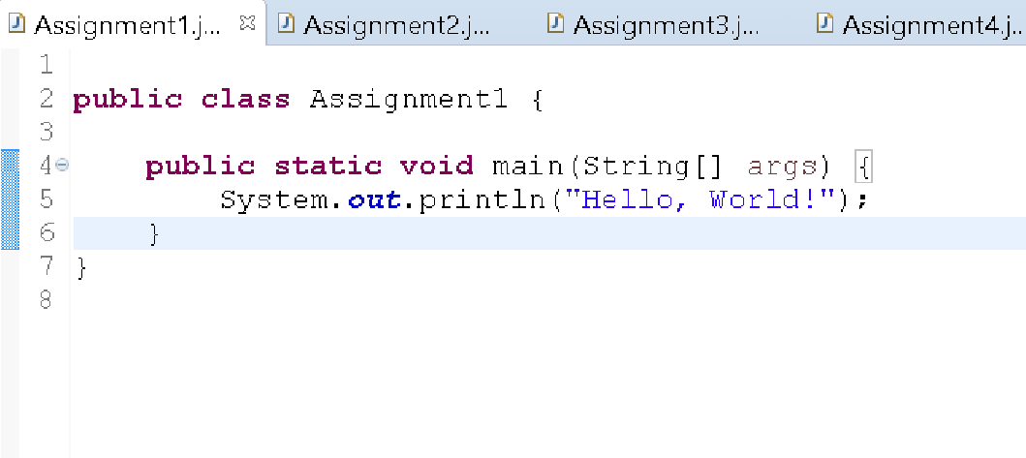

* Notice the indentation of the statement on line 5 to show that it is part of the main() method. Likewise, your code should follow this pattern.